# Method to login

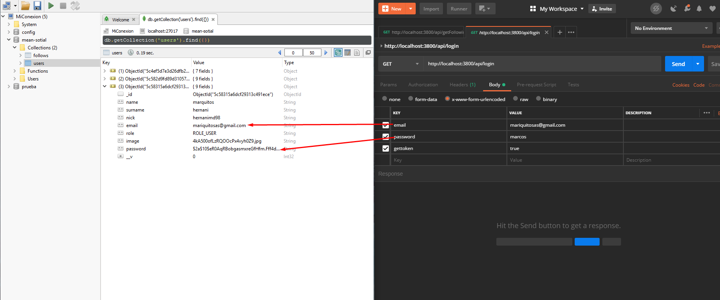

Usamos el método “get token” para usarlo en el futuro como medio de autentificación

# Update

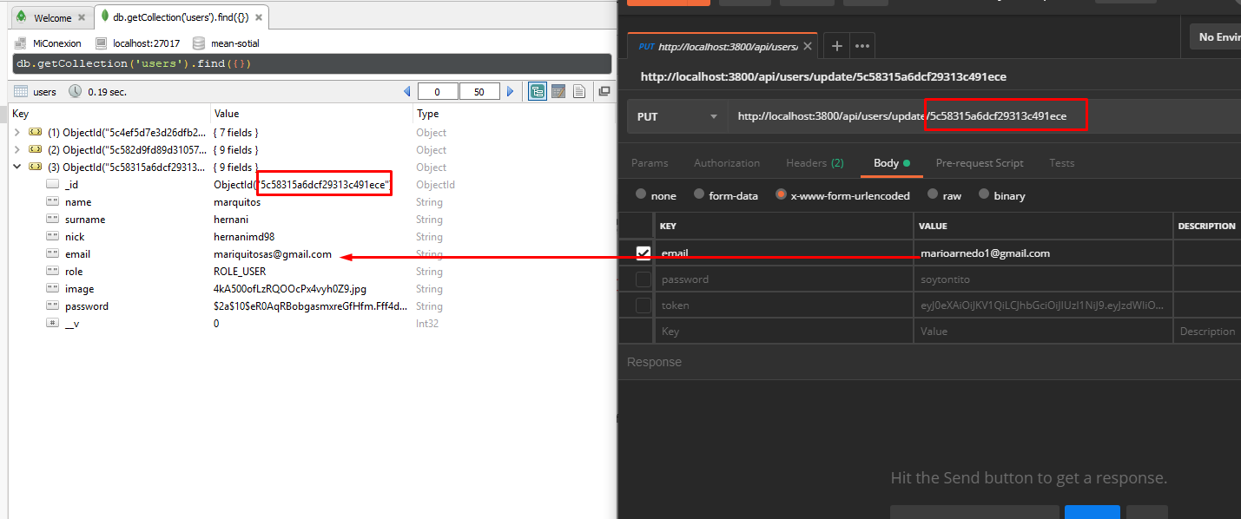U have to give the token that the login’s method gives to you in the headers:

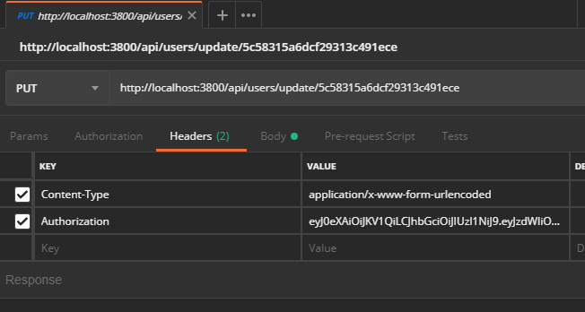

# Upload user image

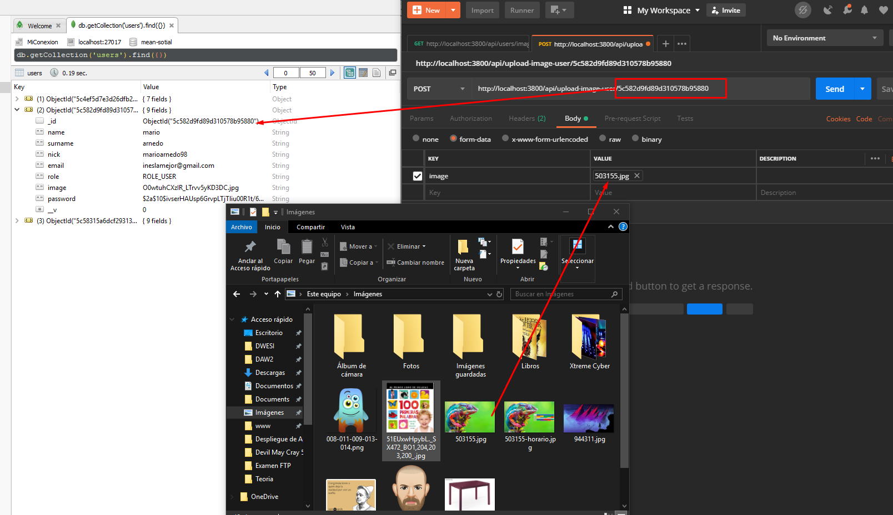

U have to pass the token:



# See the profile image from a user

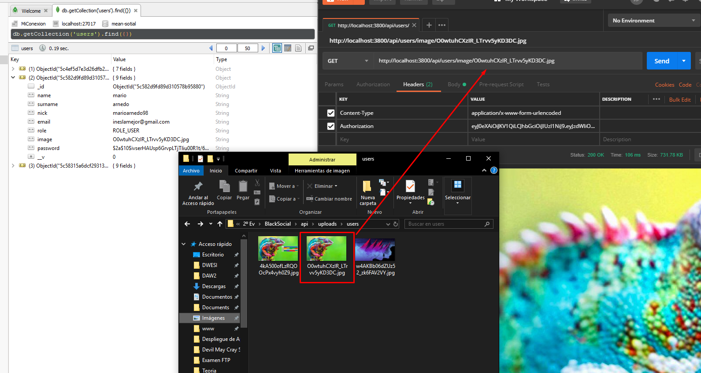

# Follow an user

U have to keep in mind that the token that u gives is the user that follows to the other people, the only think that u have to pass by get is the user and ur token

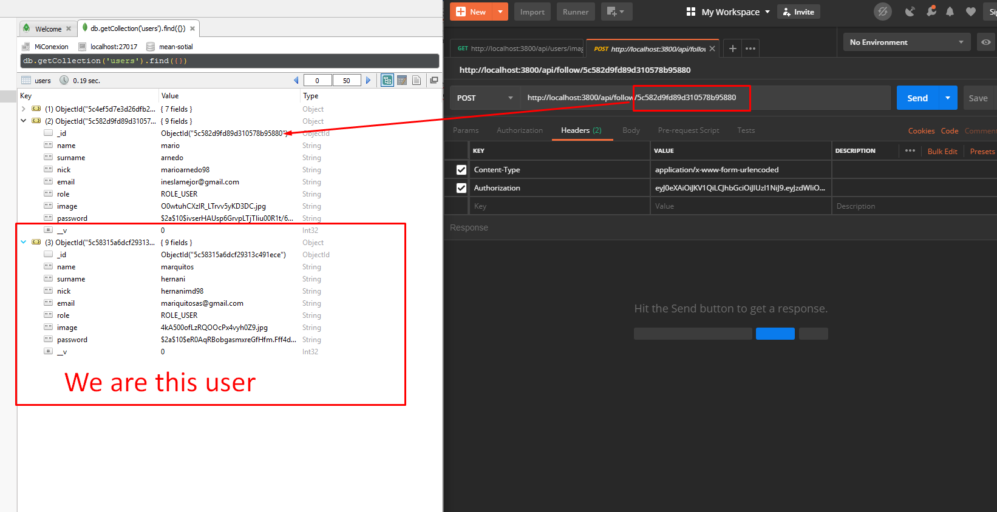

# Unfollow an user

U have to keep in mind that the token that u gives is the user that unfollows to the other people, the only think that u have to pass the user and ur token

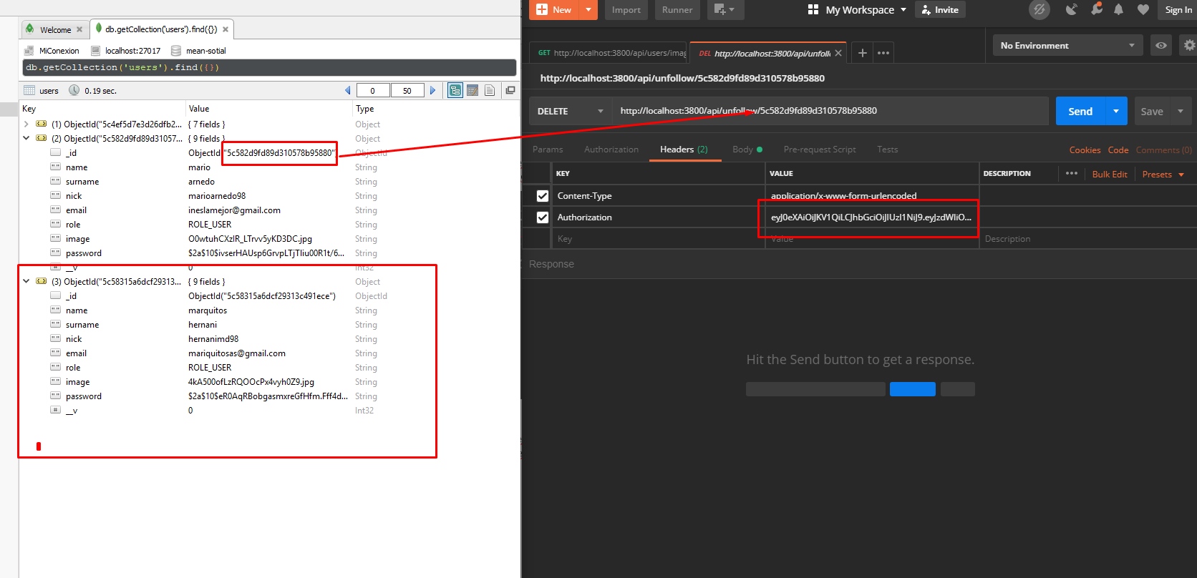

# Get Following users

U have to pass the user that u want to see the follows, and the token

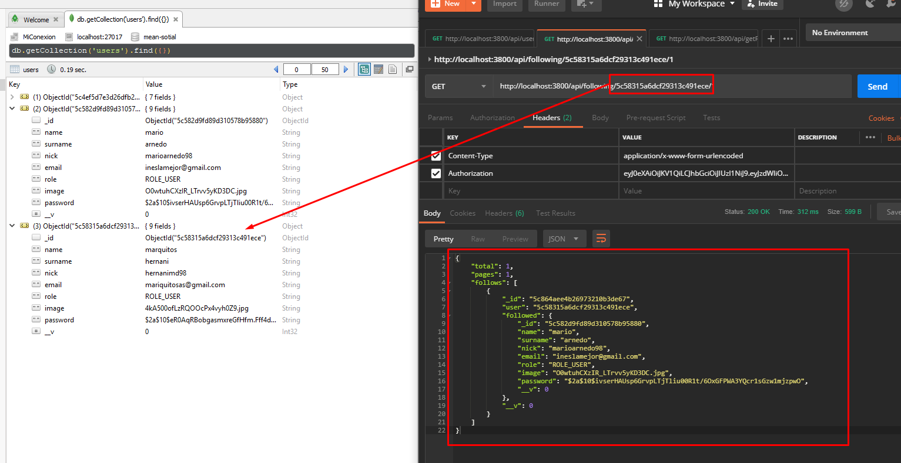

# My Follows

U have to pass the user that u want to see the follows via get, and the token

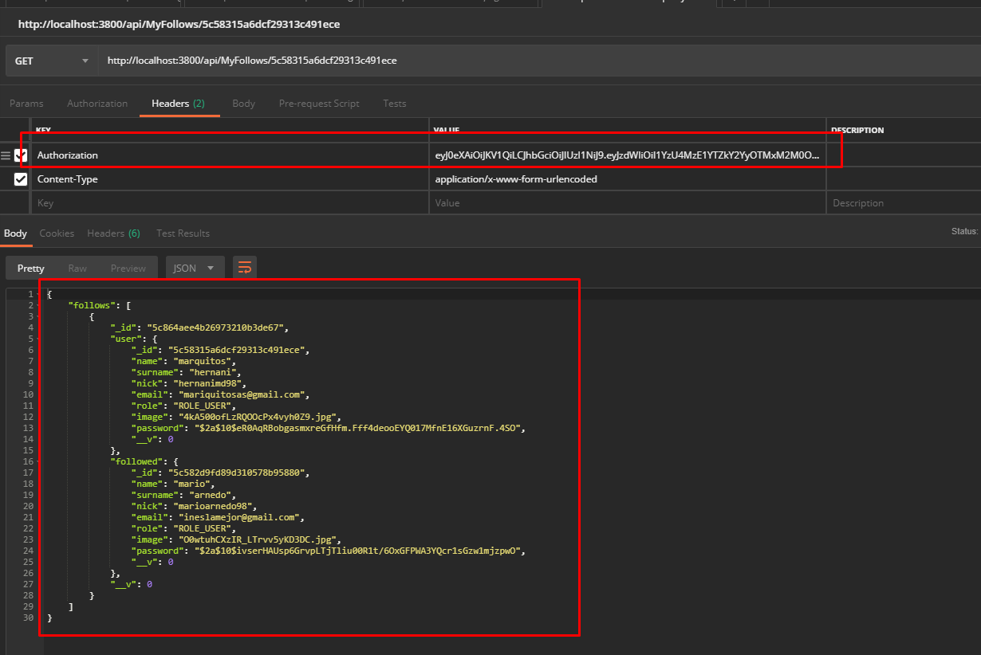

# Get Conters

U have to pass the user_id and the token

